Happy Heels Project Specification Document

Course : PG-FSD-Implement-Frameworks-the-DevOps-way and part of PG FSD Caltech program

Programmer Details: Hardik Joshi

**Screenshots of all Scenarios in the Application:**

* **Customer Related Scenarios**

**Homepage of Happy Heels website: displays options for customers to login (if they already have an account or Sign Up if they are new customer)**

**Shop Option where they can shop for shoes .**

**Cart Option – see cart contents**

**Buy button which will direct them to shop page to buy products.**

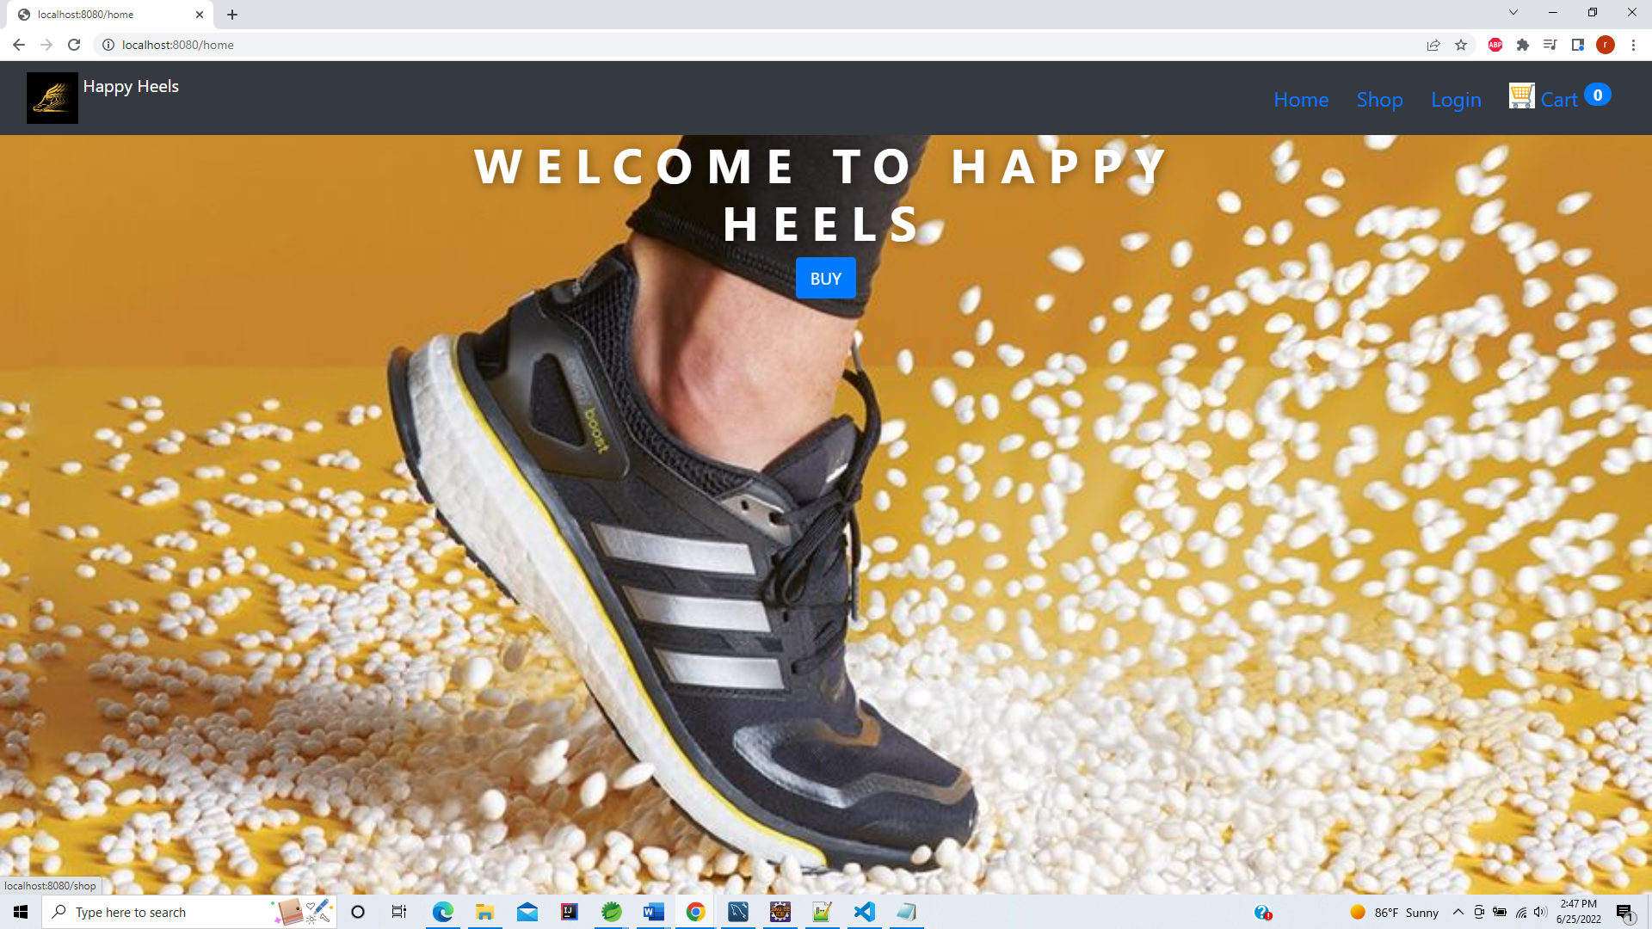

**In Shop page user will see list of All products if the category is not selected from the sidebar, User can also select individual categories and purchase products from there**

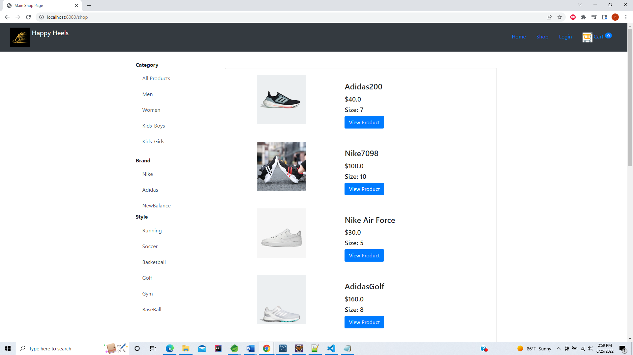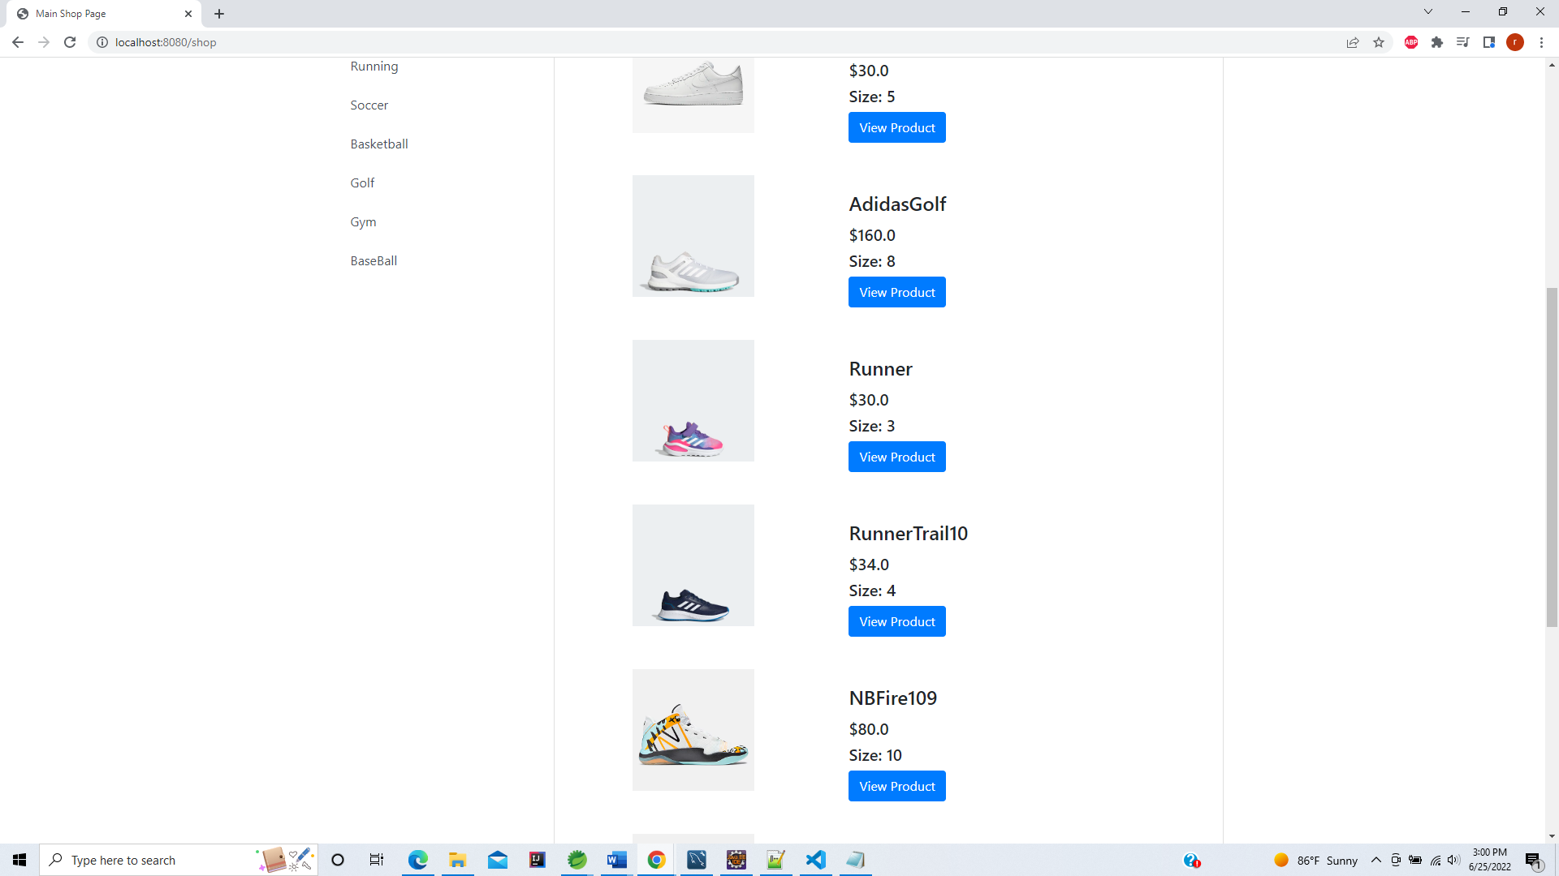

**Selecting Women**

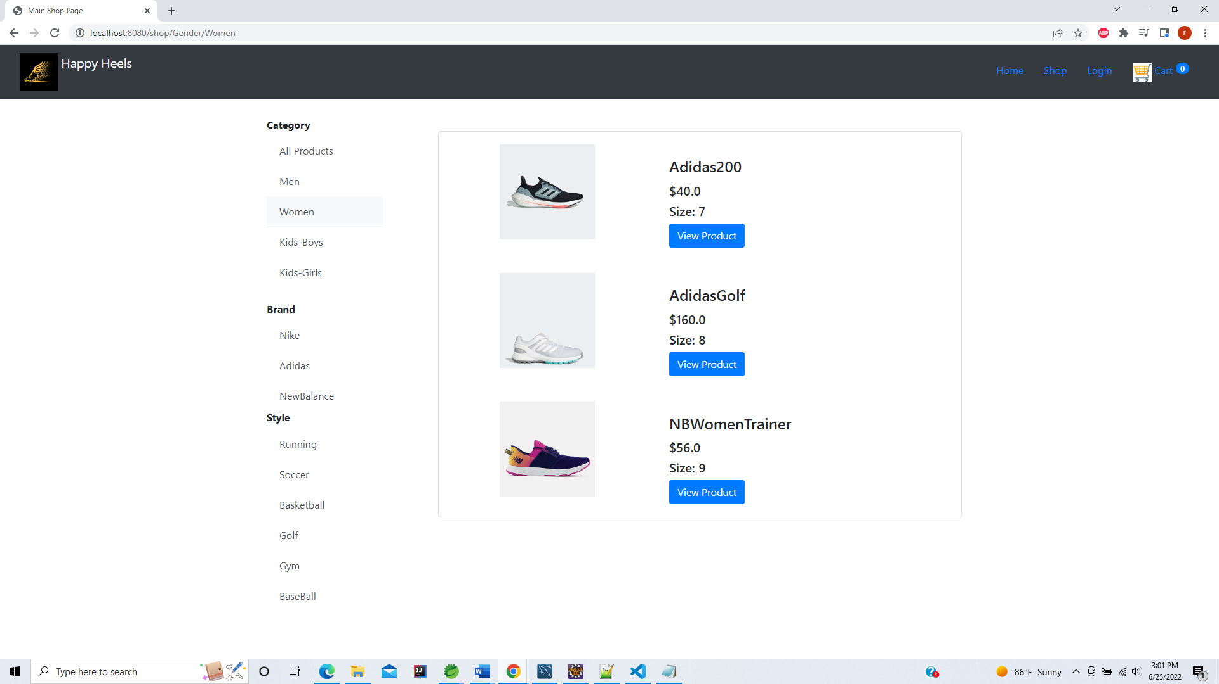

**Selecting Kids-Boys**

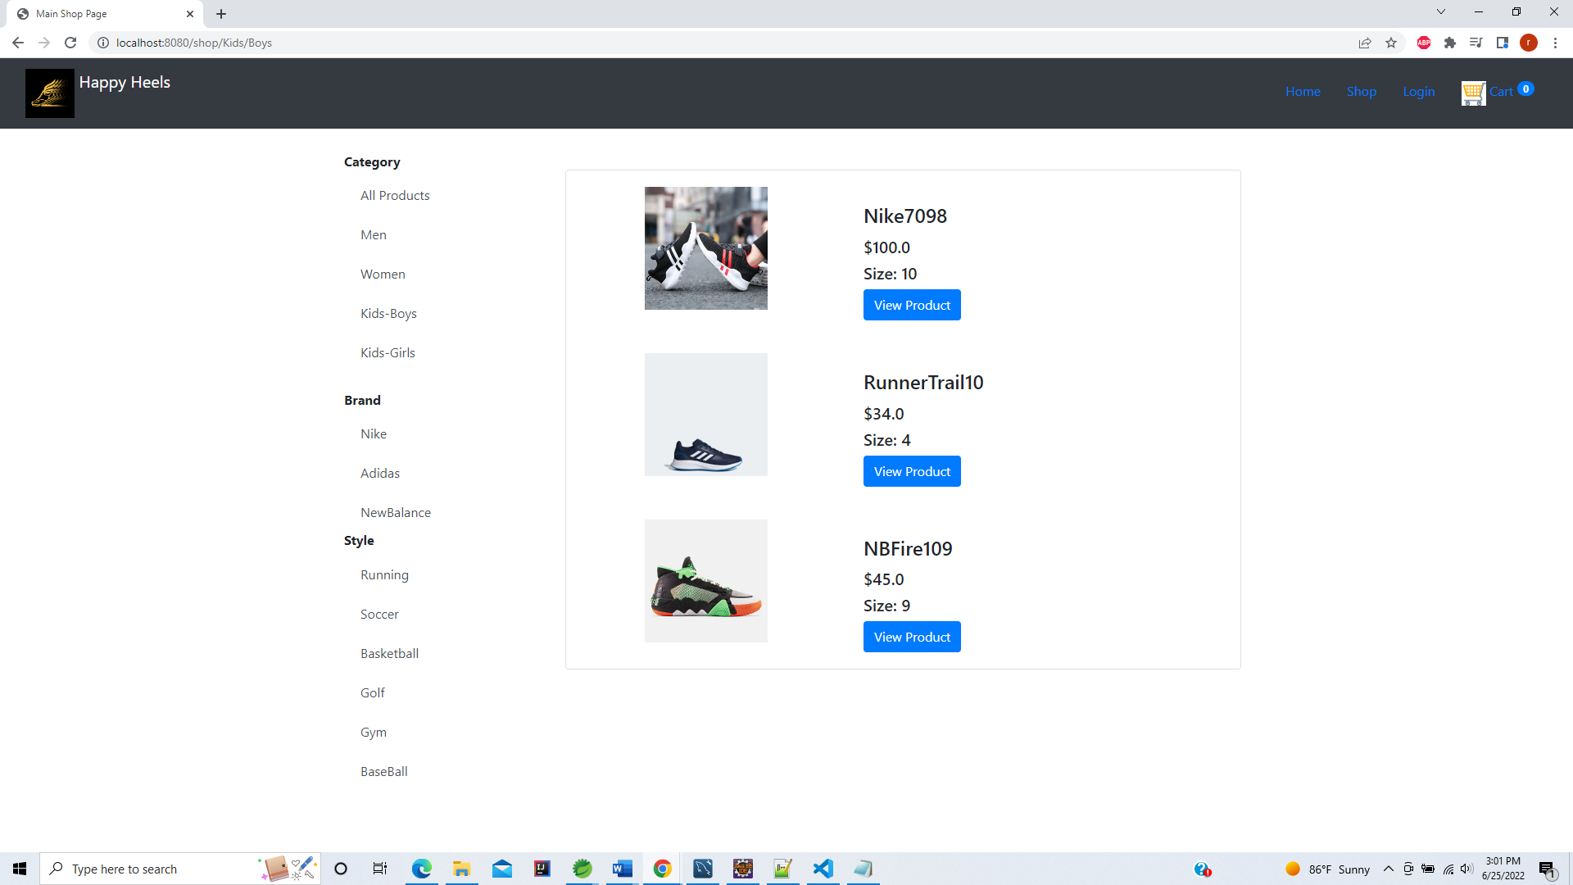

**Selecting Brand - Addidas**

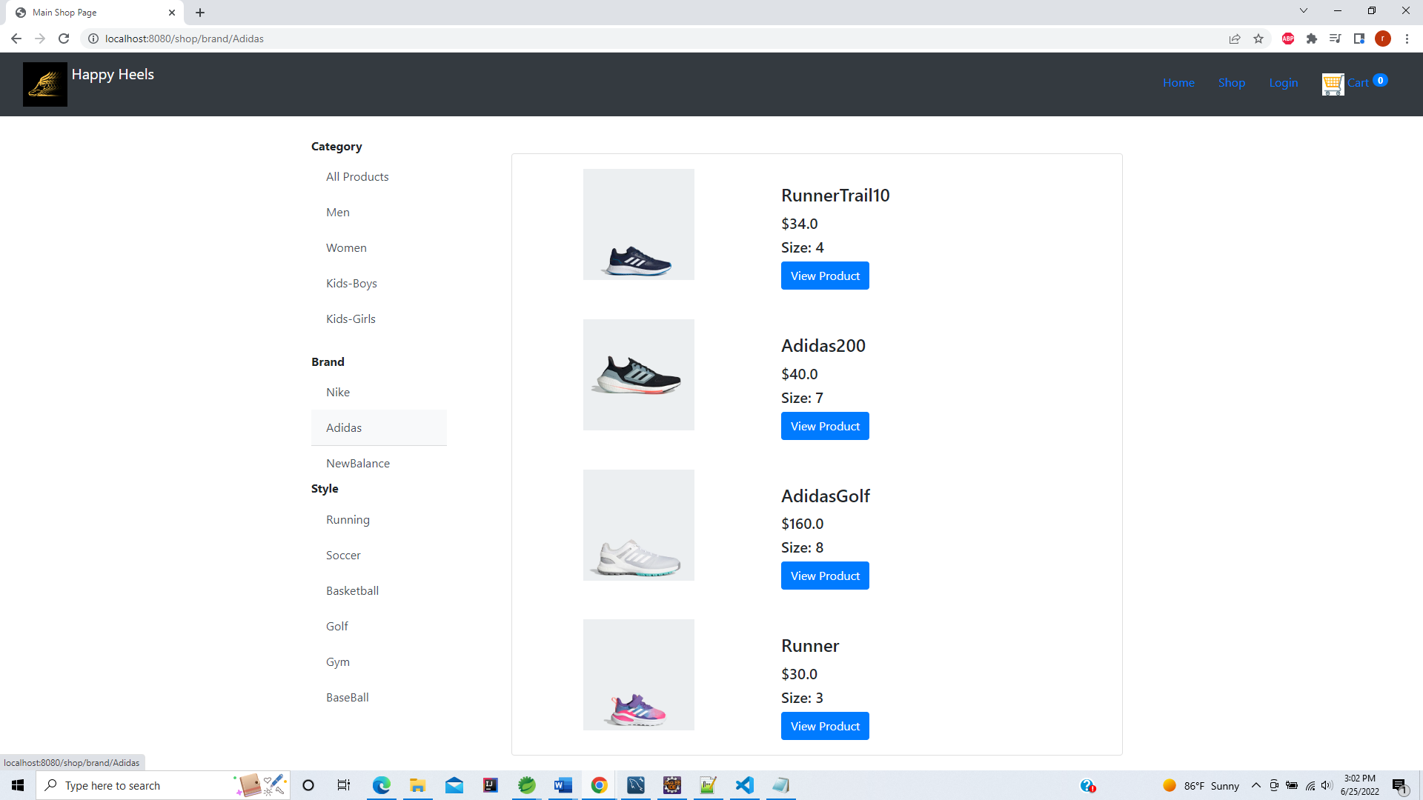

**Select Style : Running**

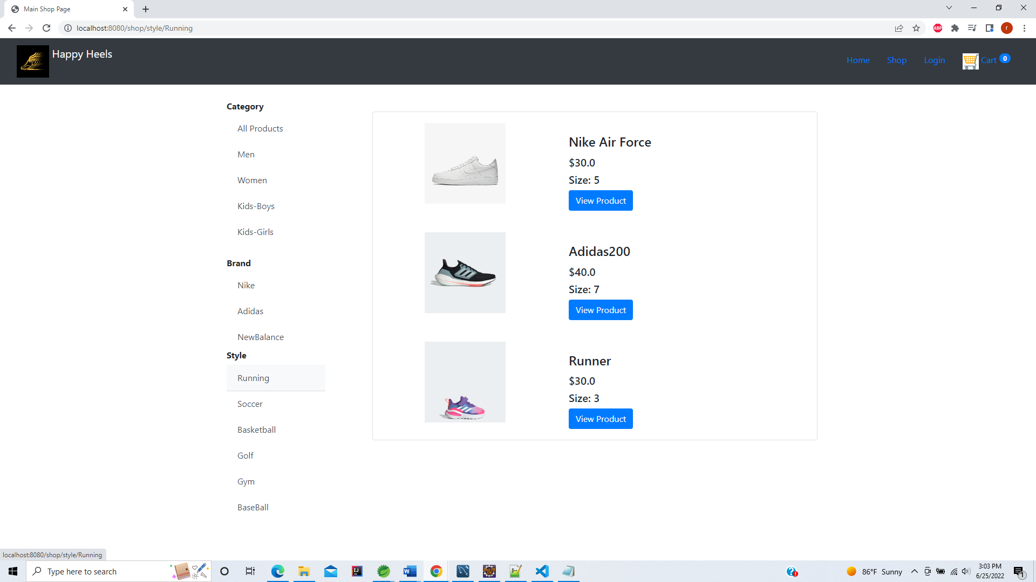

**View Product**

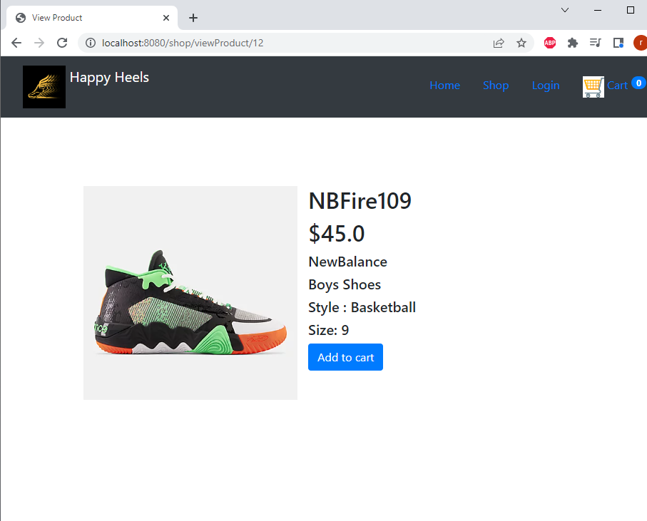

**Add to cart – Cart is updated**

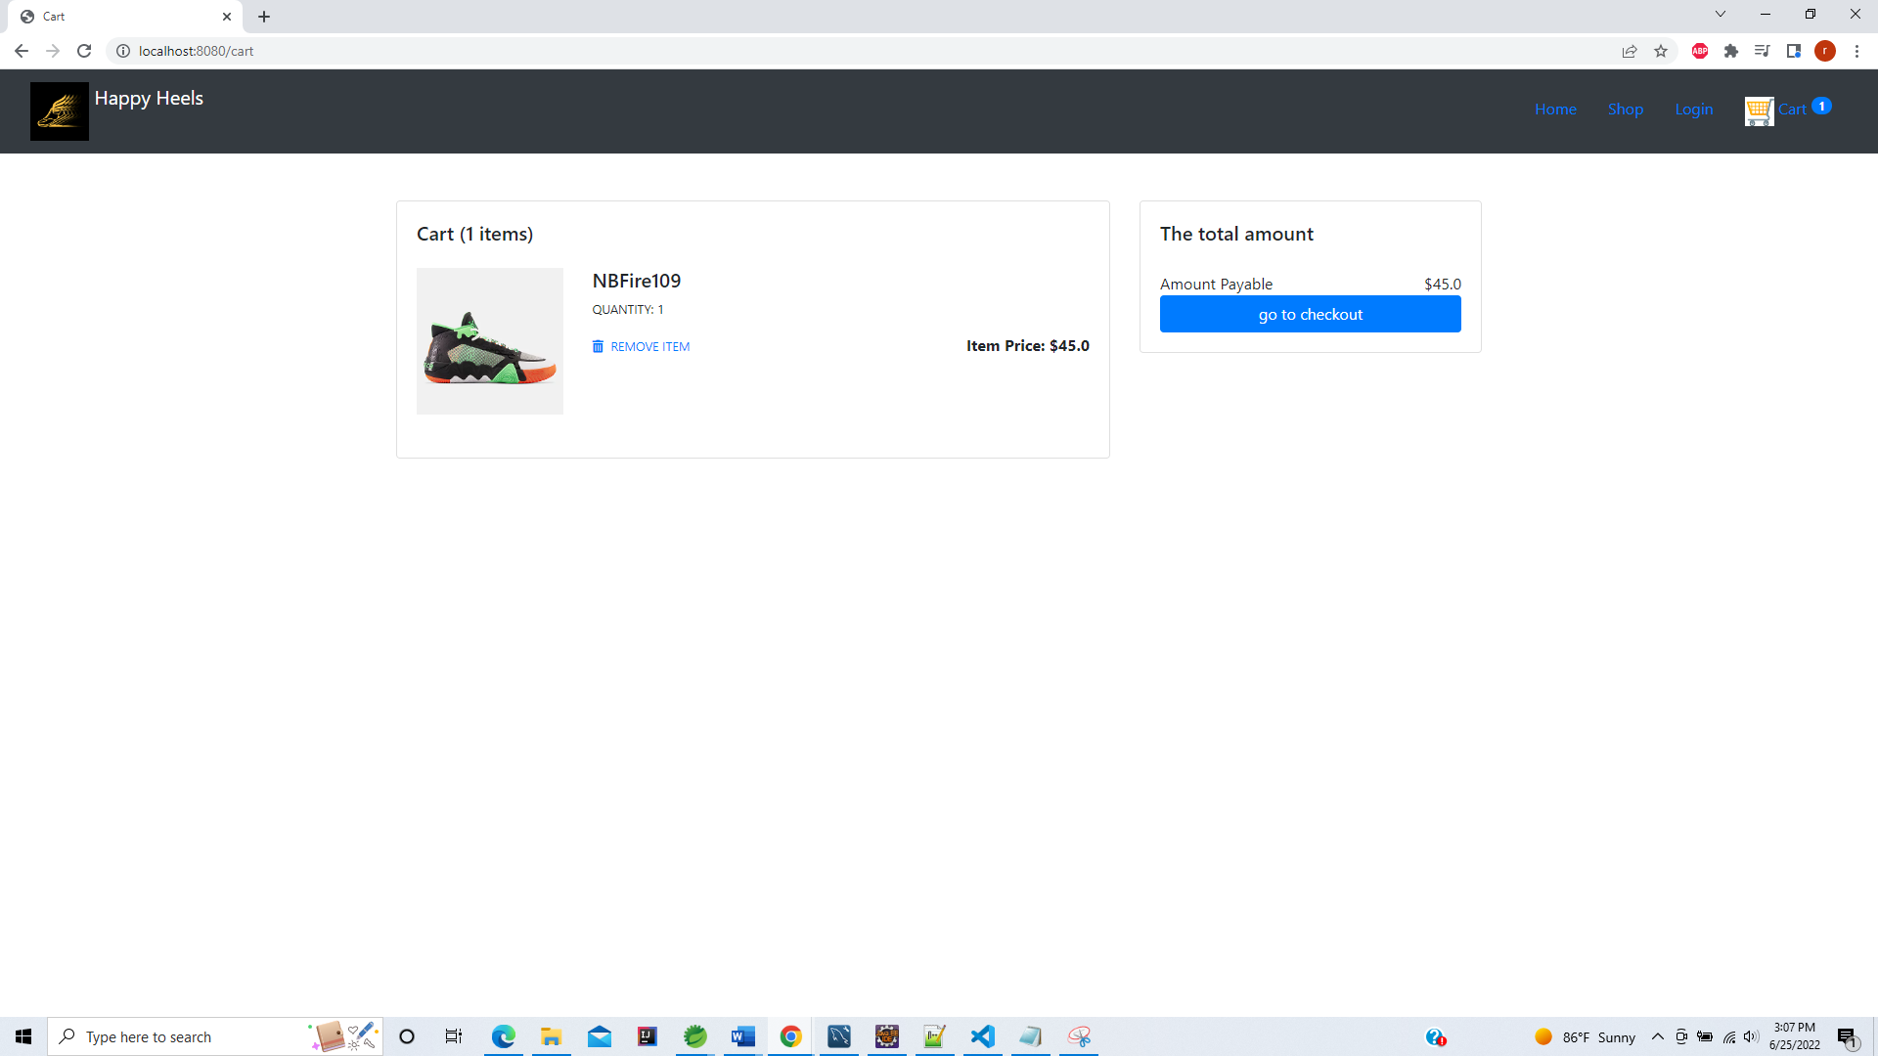

**Adding multiple shoes into cart. Cart Items updated and total updated amount shown.**

**Option to remove item from cart.**

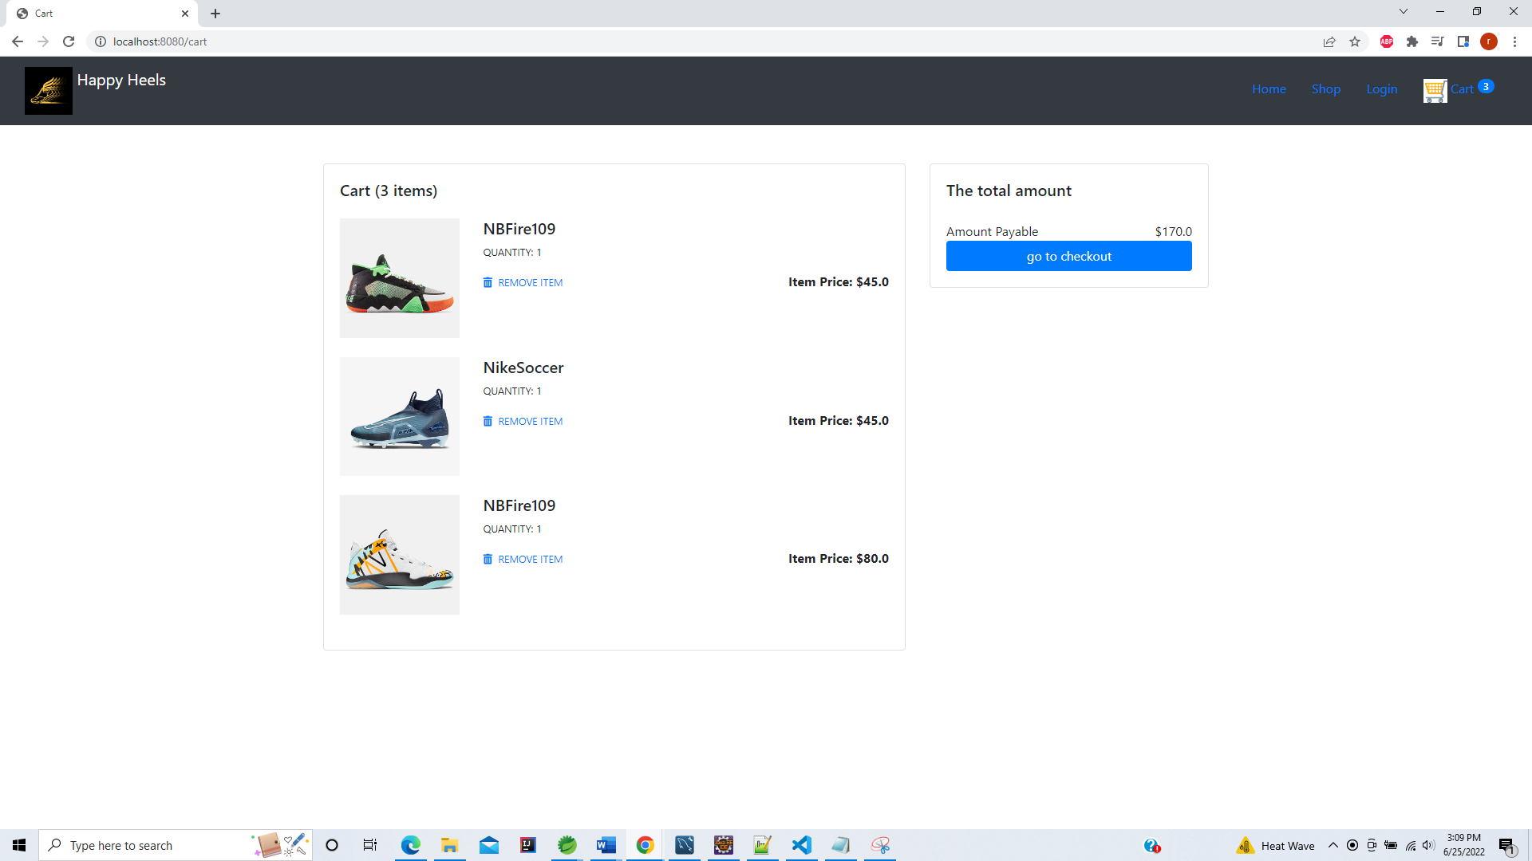

**After removing first Item**

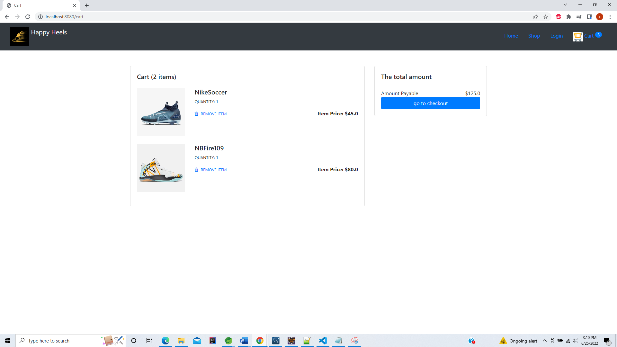

**Can add multiple items of same type – You see Qty has been updated for NBFire109**

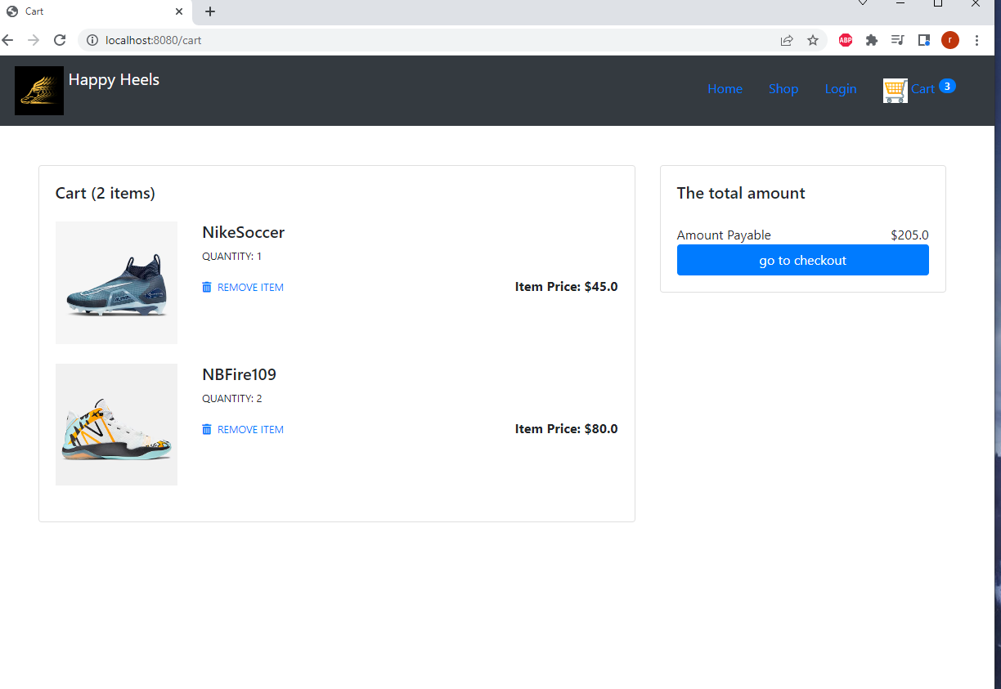

**Also Nav bar Cart icon – shows updated cart items**

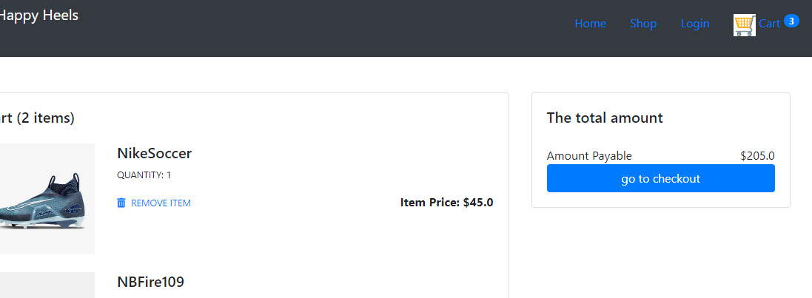

**On clicking checkout if Customer is not checked in proper error message shown asks Customer to login first.**

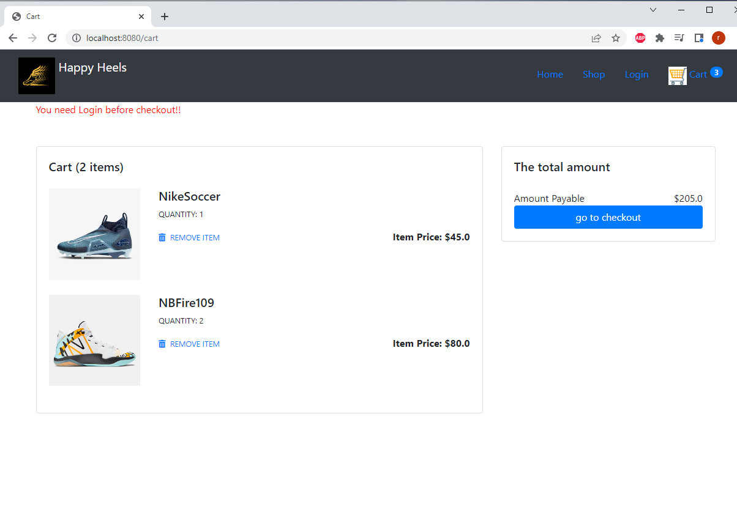

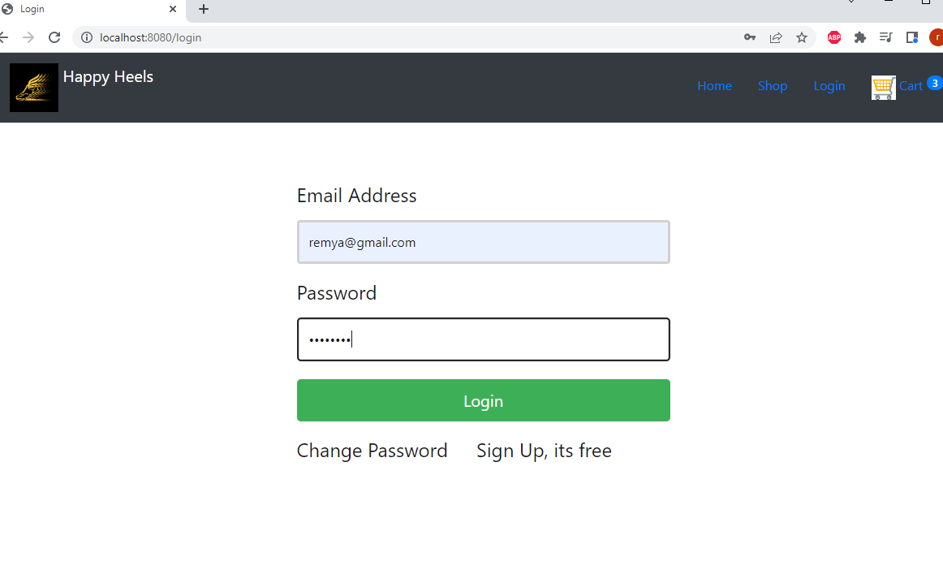

**After Login user name is shown in nav bar**

**Also note the cart Items previously added are still shown -3**

**In nav bar shows Logout button**

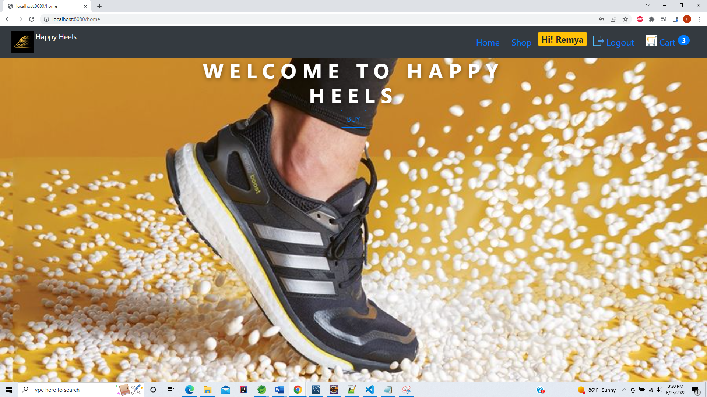

**Clicking cart icon from navbar shows cart details**

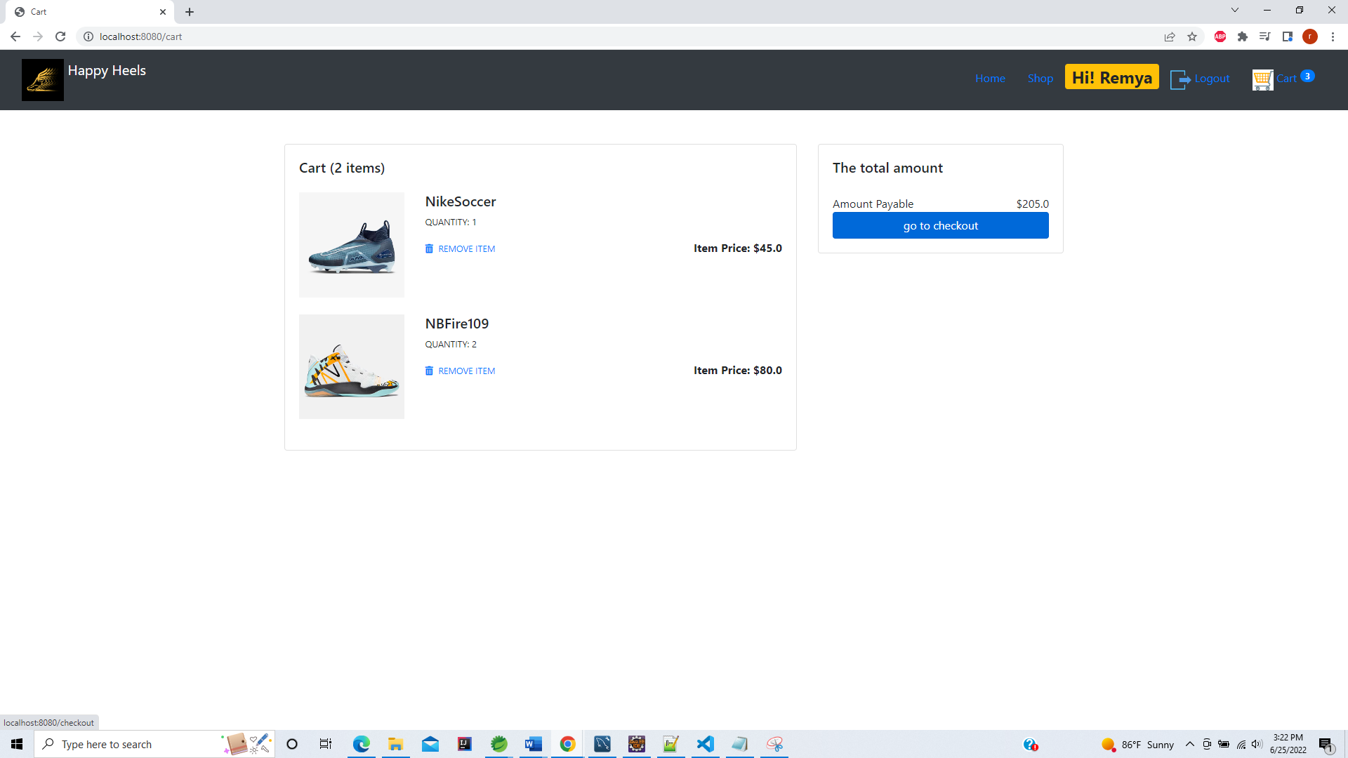

On clicking checkout – Asks users for Billing details

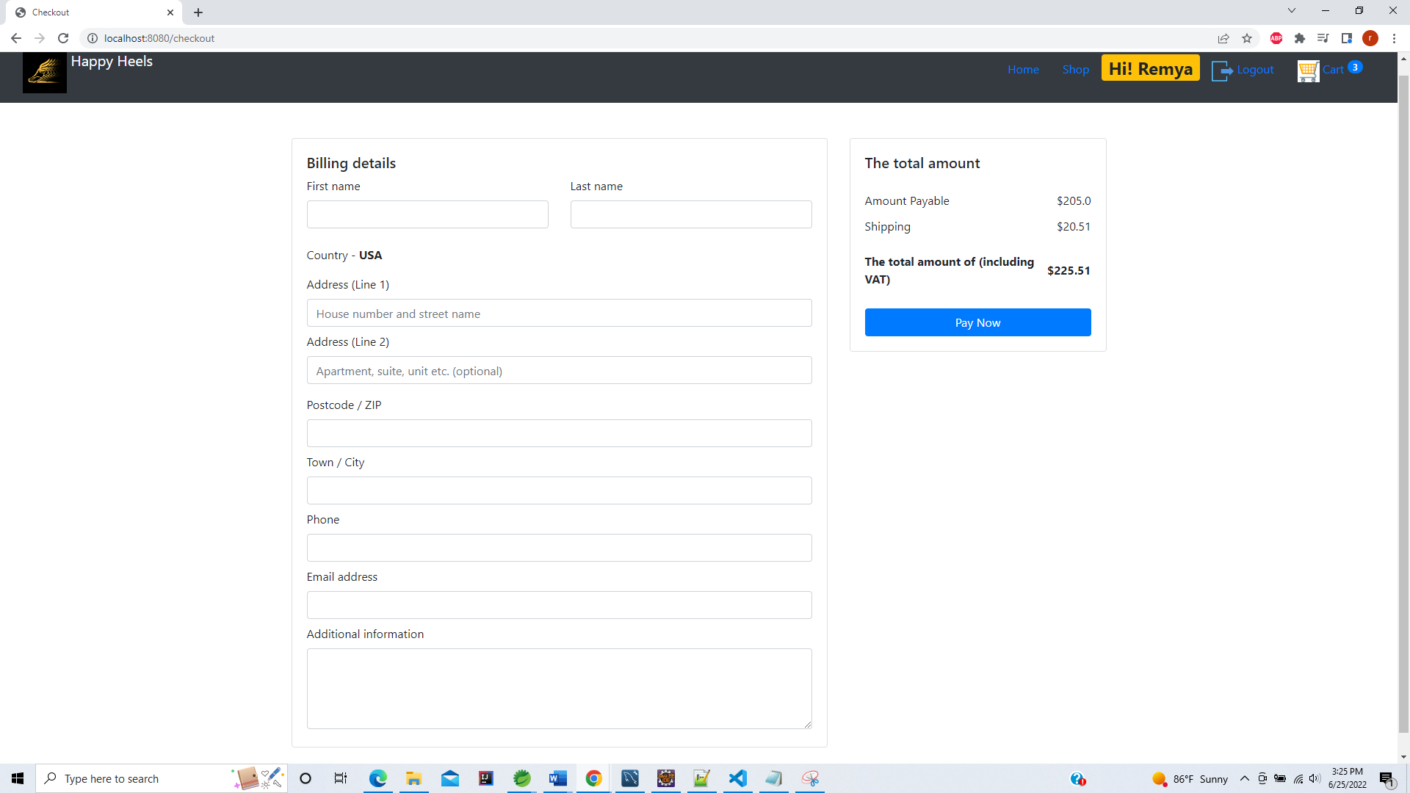

Customer fills in the details

The Total Amount shown ( with Shipping charges and Tax included)

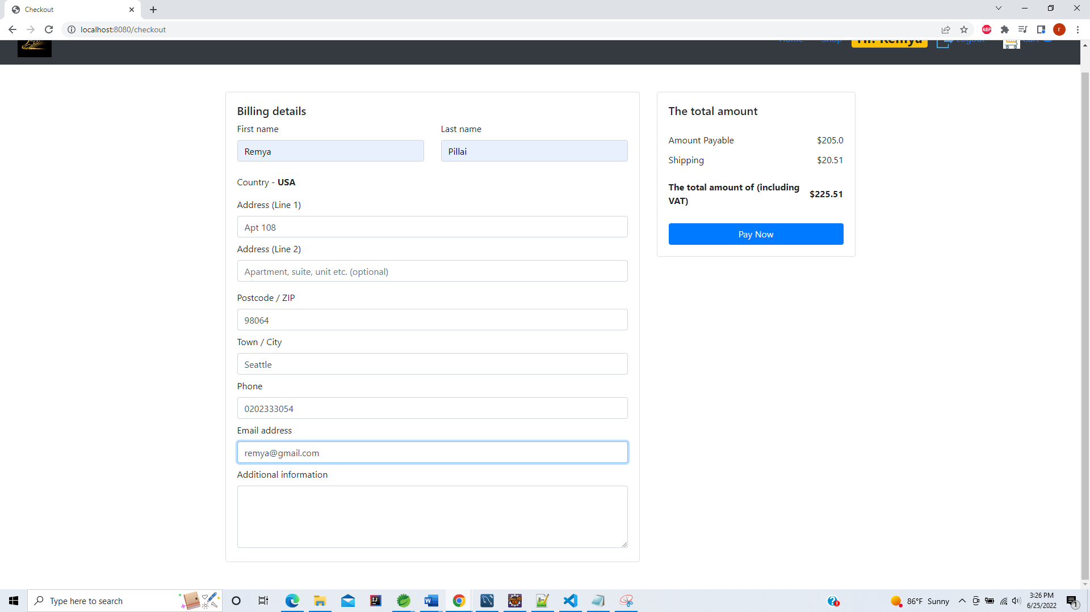

Payment Confirmation Page with order No.102

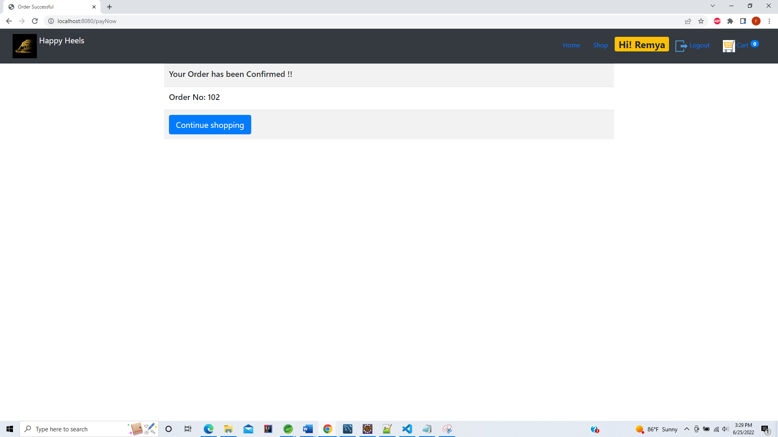

Data base is also populated with Order Details

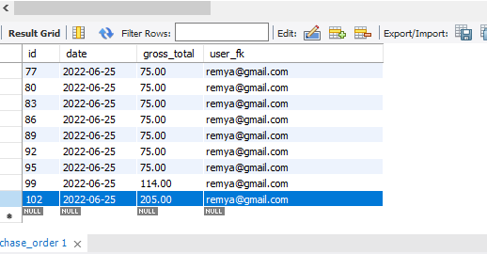

And Purchase item details for each item

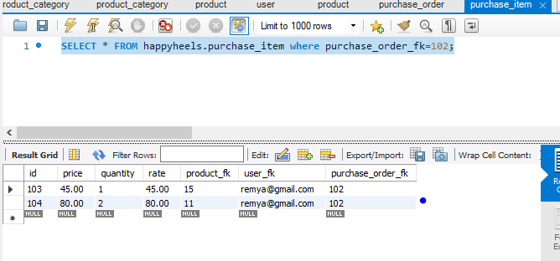

Continue Shopping brings you back to shopping Page

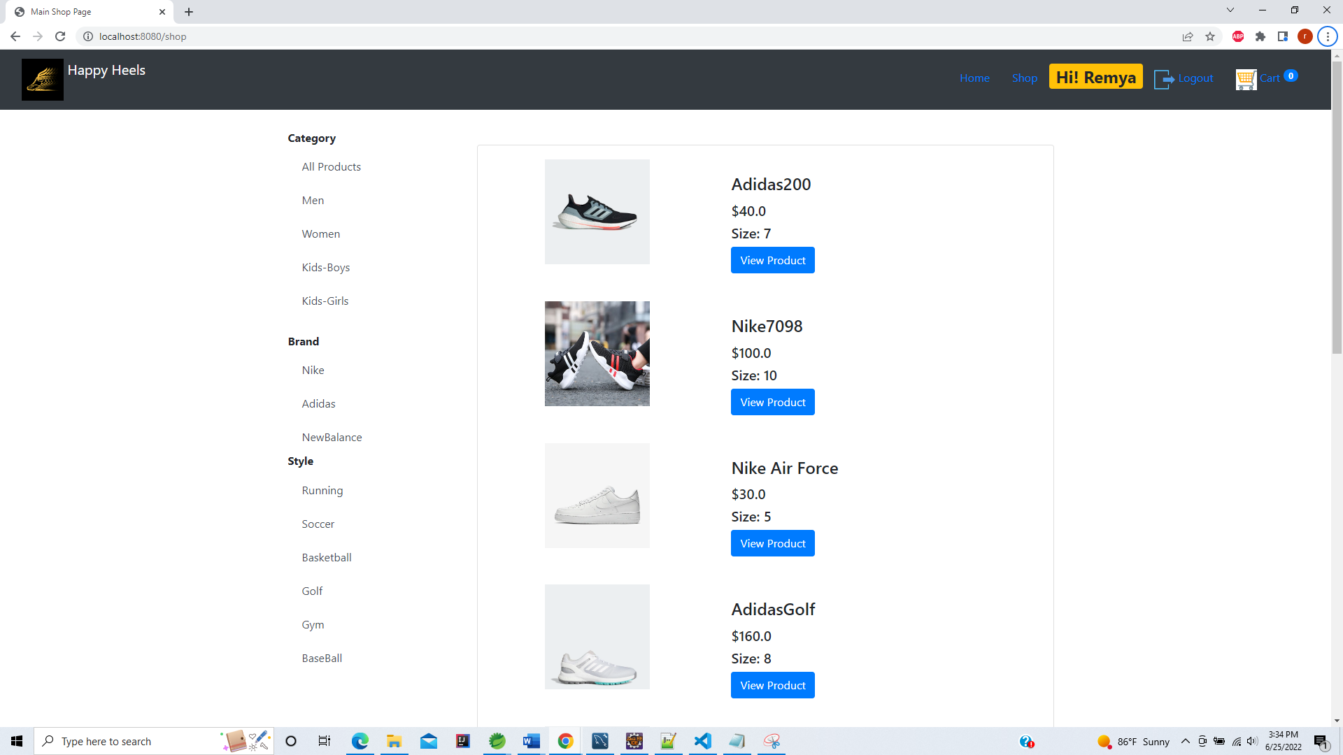

Cart is now updated to empty

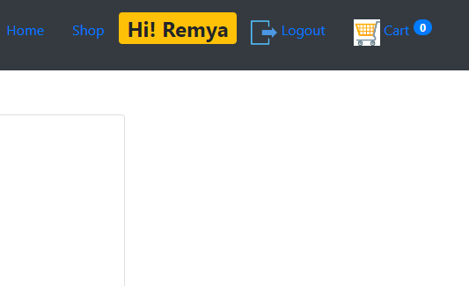

After clicking logout

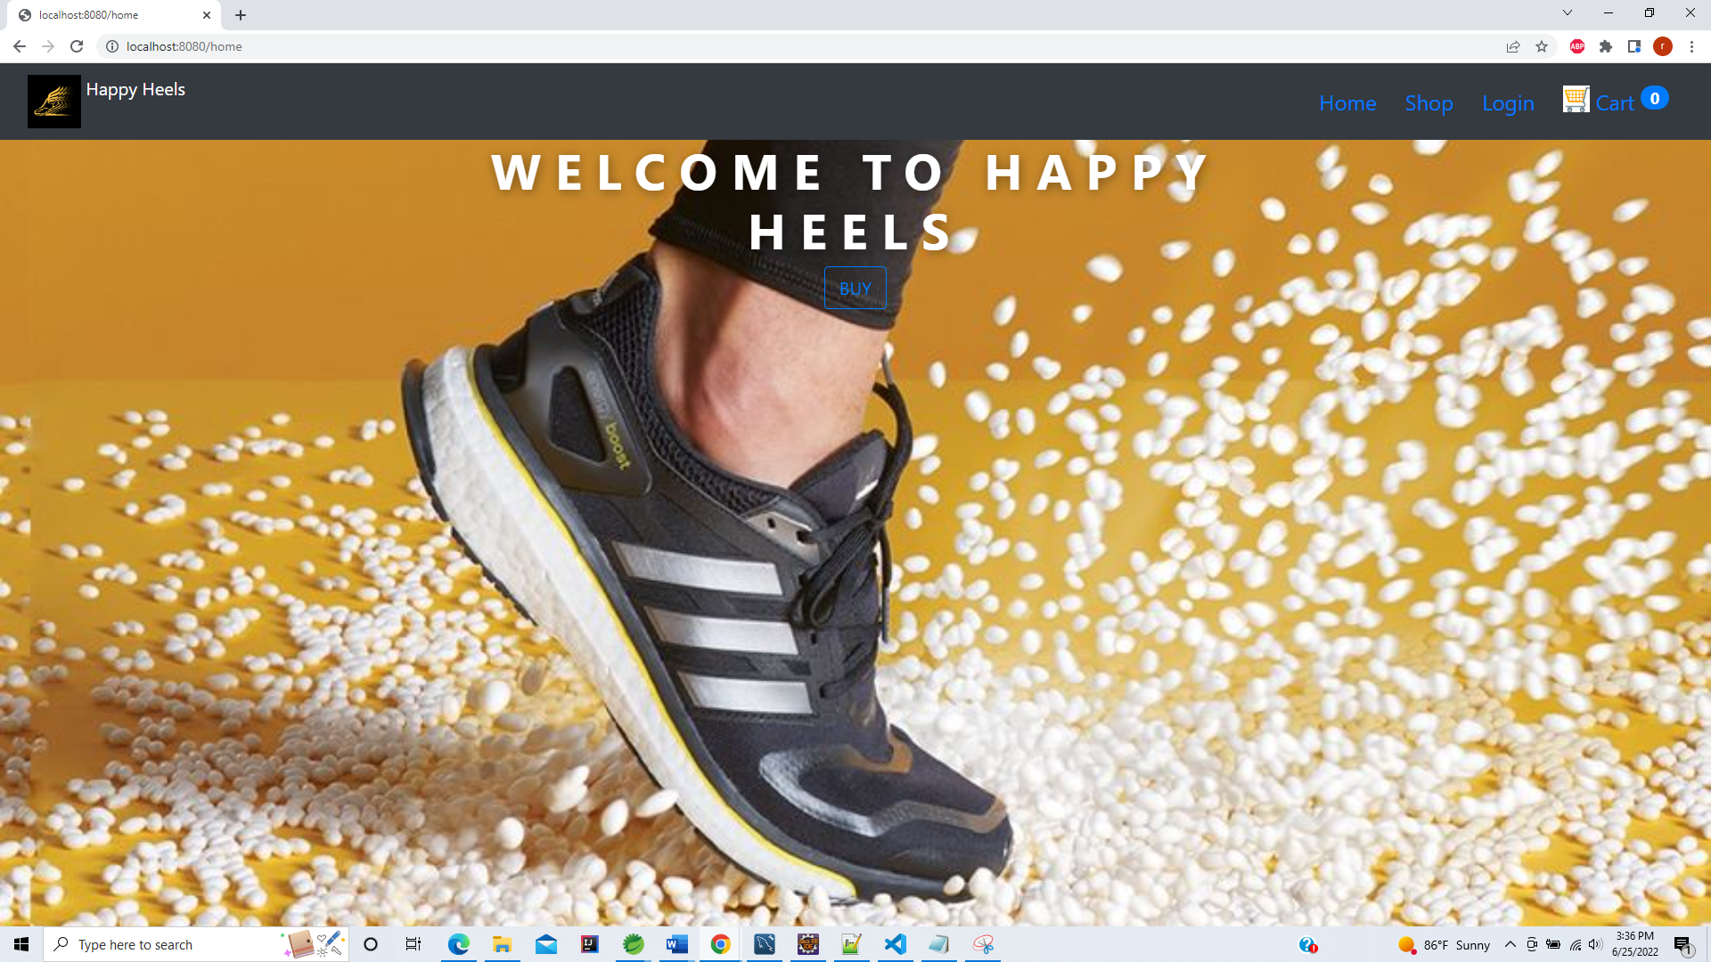

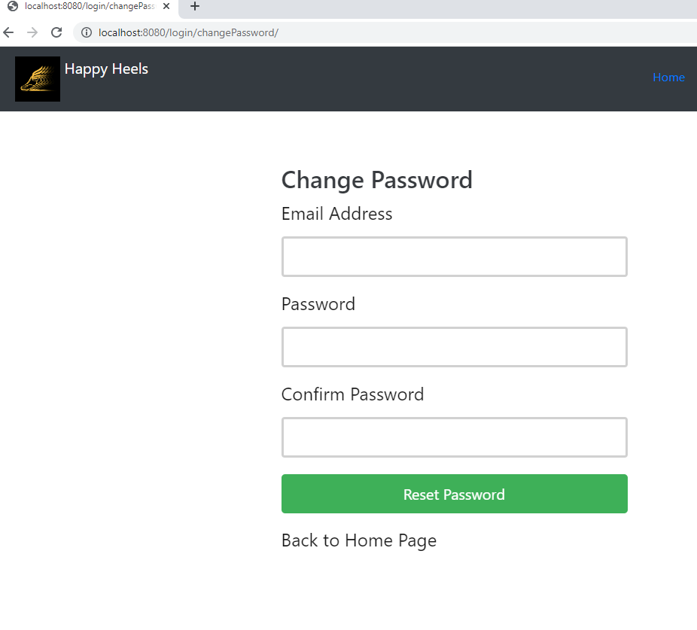

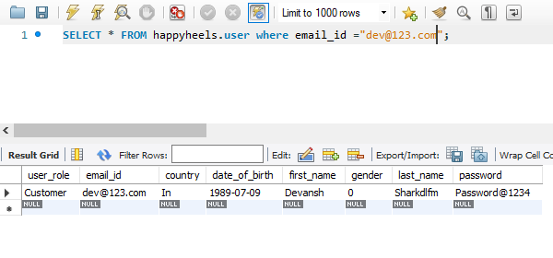

After changing password

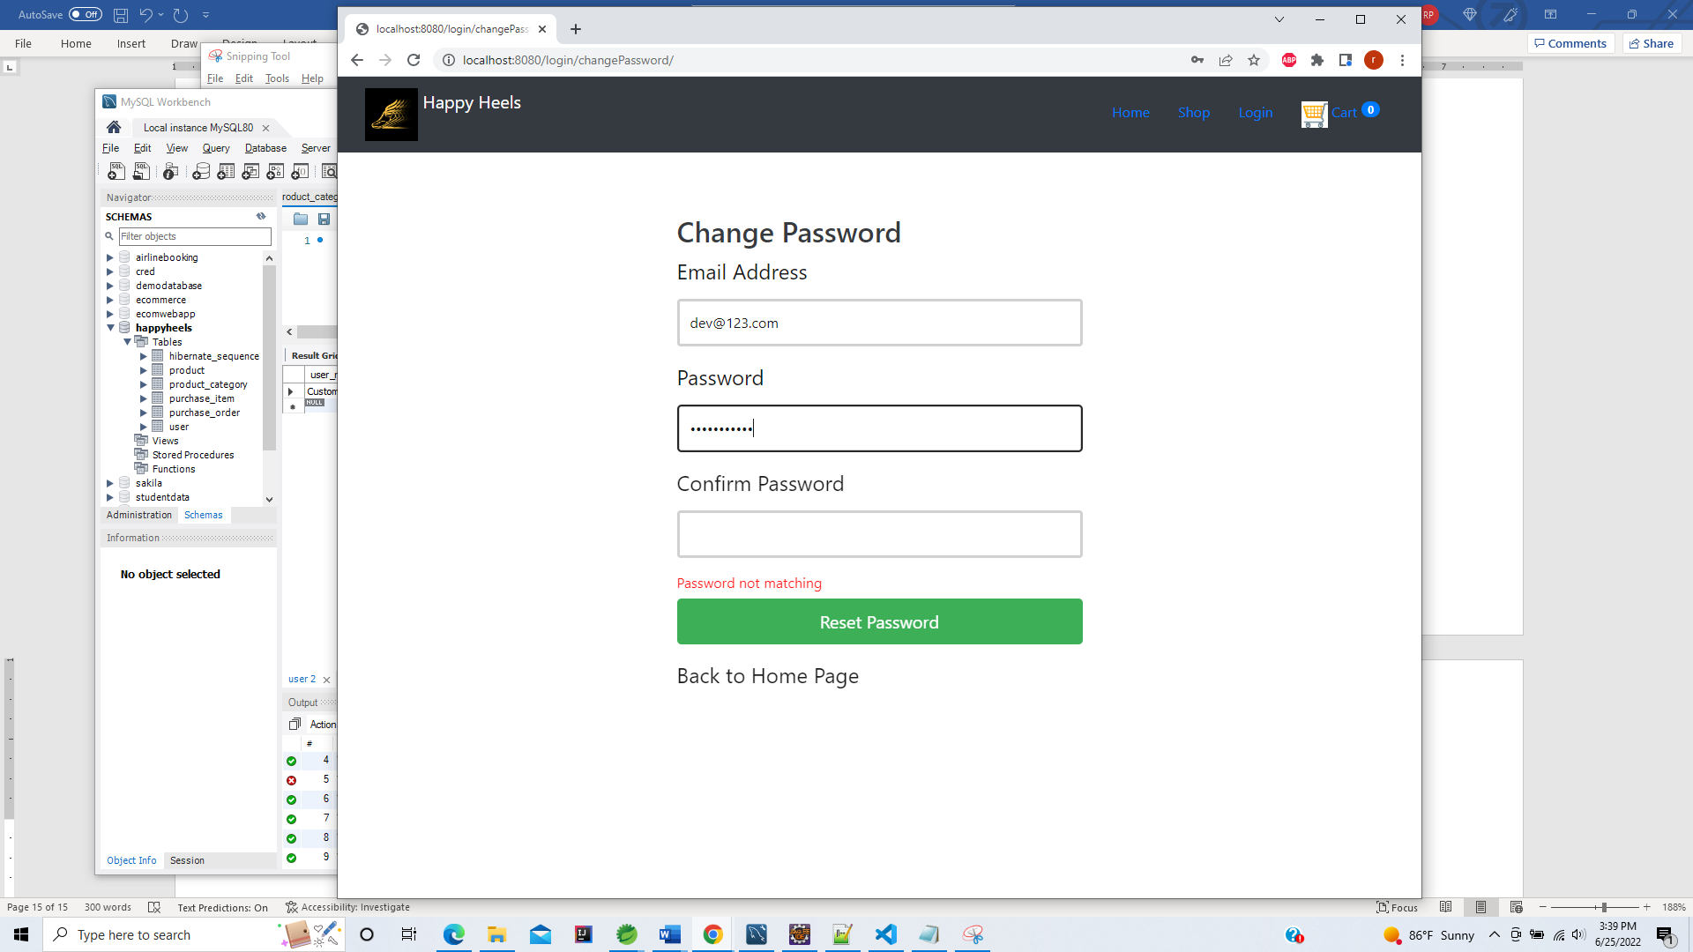

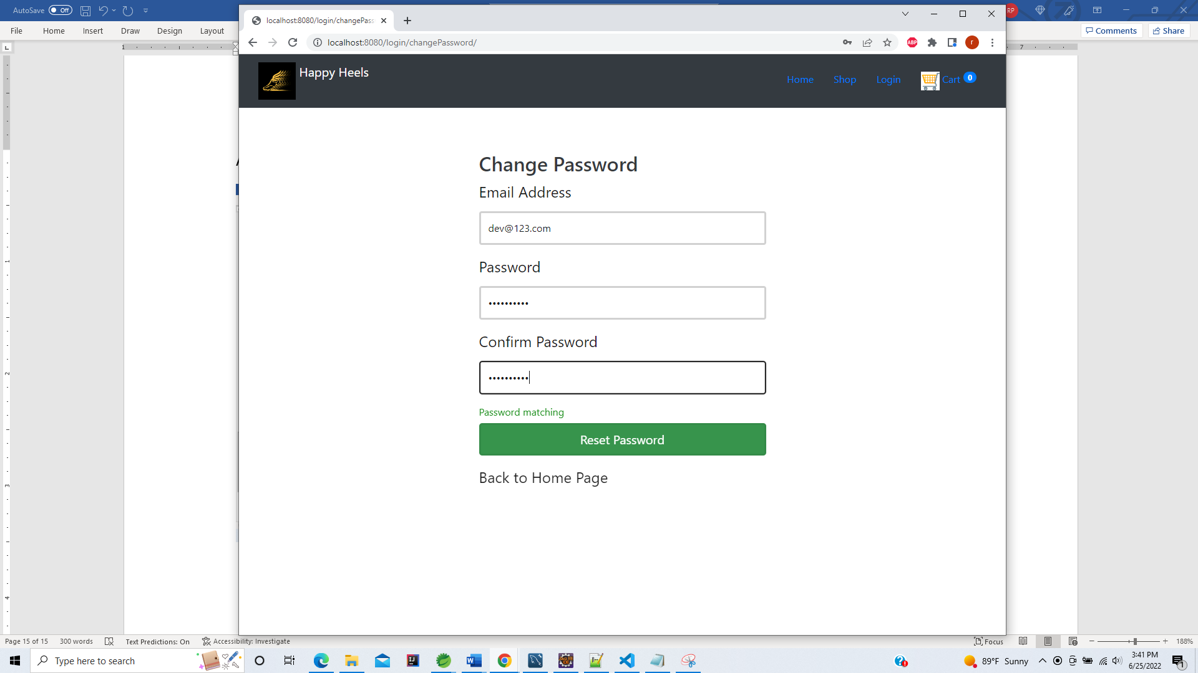

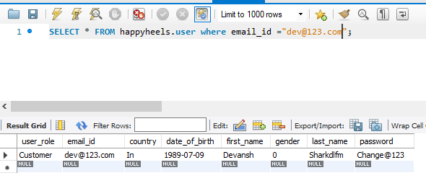

New Customer Registeration

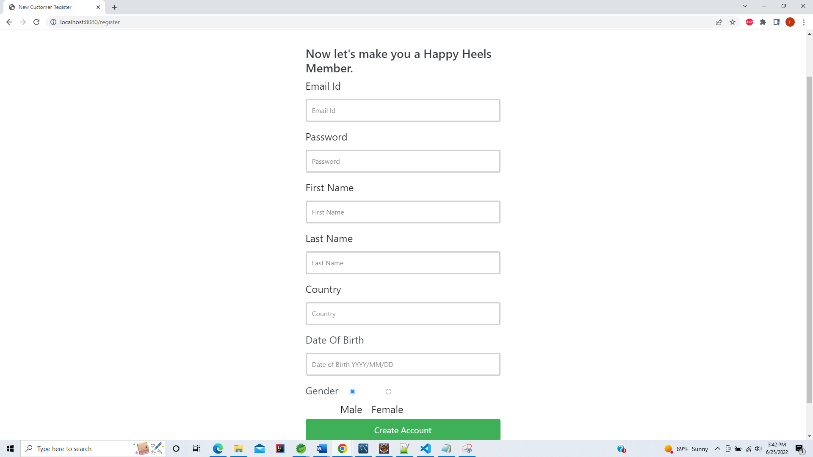

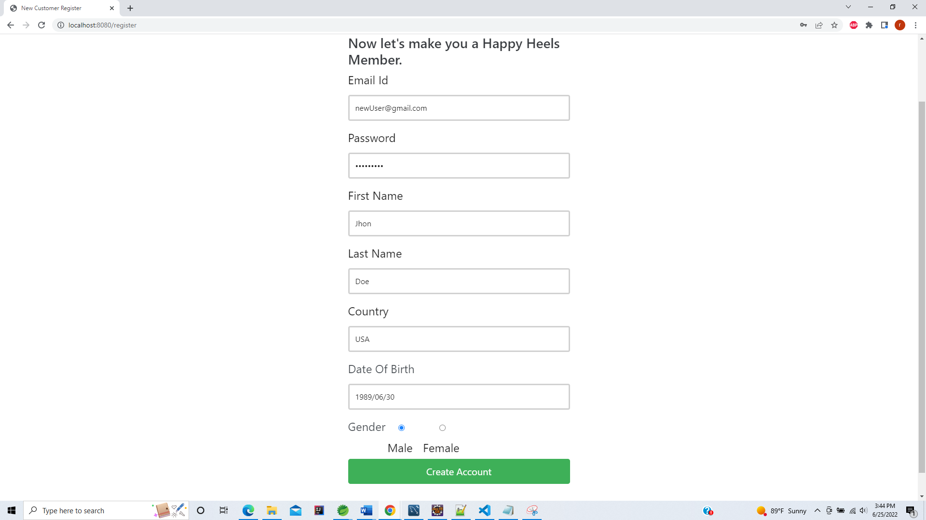

New user is added to DB with filled details and user Role as Customer

